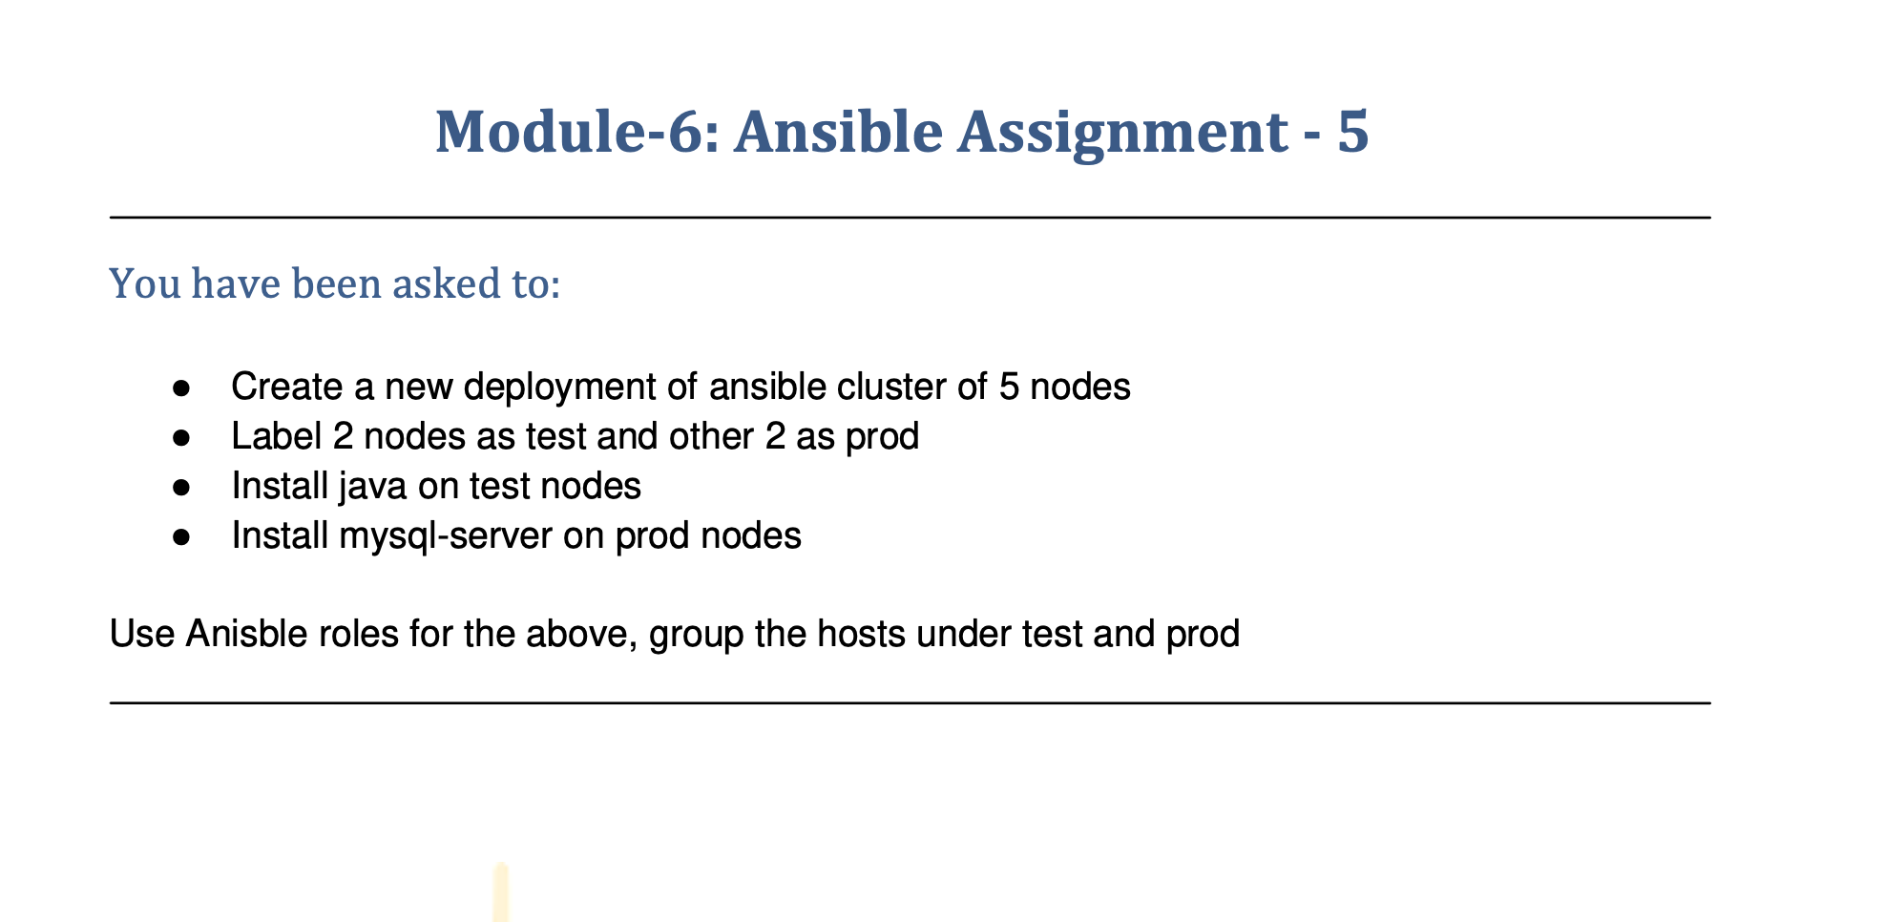

You have been asked to:

* ●  Create a new deployment of ansible cluster of 5 nodes
* ●  Label 2 nodes as test and other 2 as prod
* ●  Install java on test nodes
* ●  Install mysql-server on prod nodes
* **ASSIGNMENT 5**
* **Create 2 new nodes:**

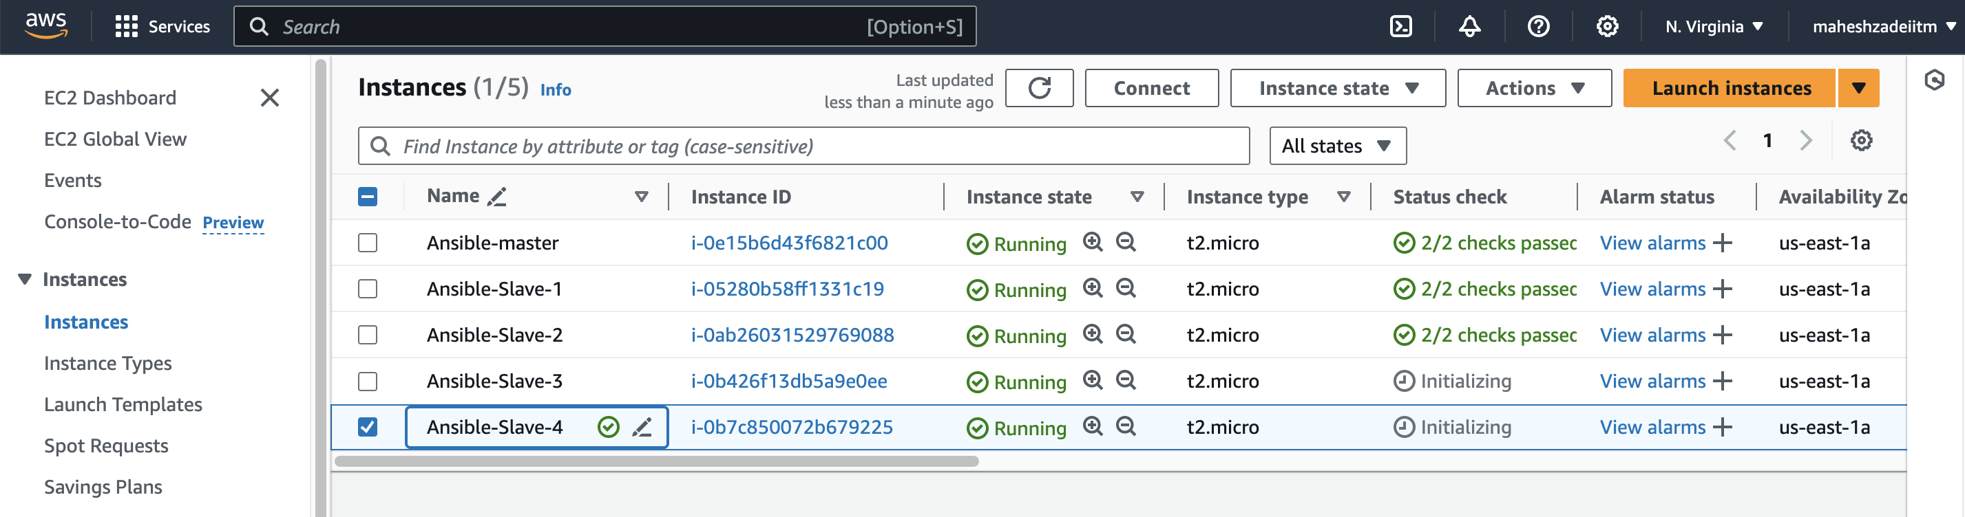

* **Connect these nodes using ssh-keygen to Master node**

**Go to master EC2 and copy the ssh key as per below command**

**ssh-ed25519 AAAAC3NzaC1lZDI1NTE5AAAAIIzBsxWWjIvyQco5wPo8AQdV2X4Bfpyb3p9SEdc1uSIz**

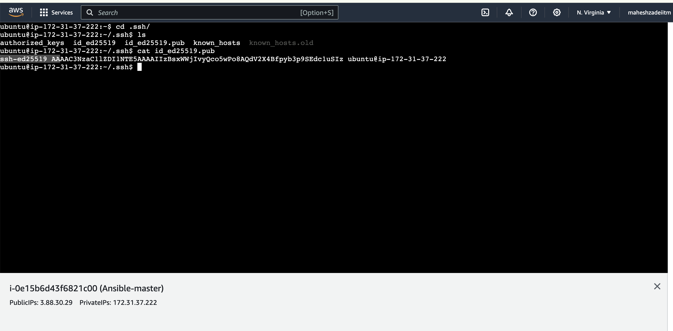

* **Now go to Slave3-Ec2 machine and paste in below path**

**ubuntu@ip-172-31-39-28:~/.ssh$ sudo nano authorized_keys**

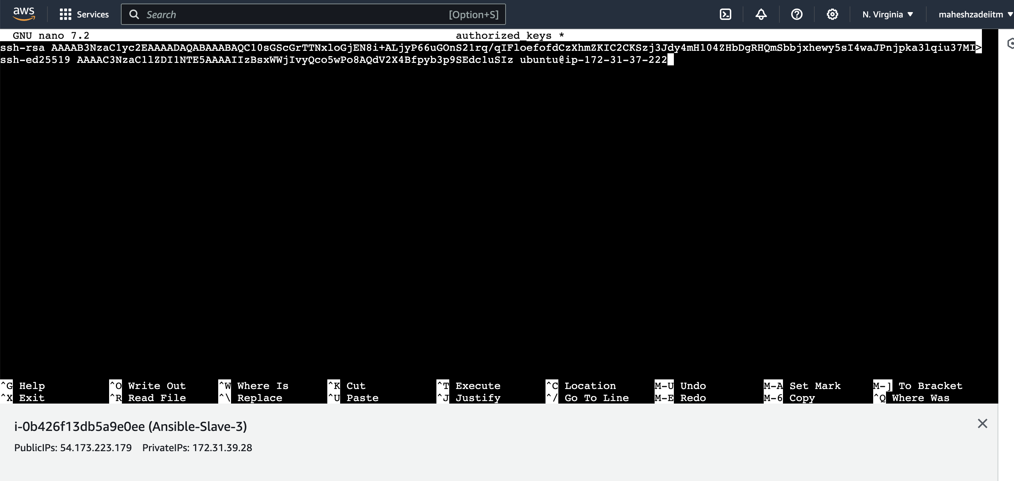

**Similarly copy key in slave 4 EC2 machine/Server**

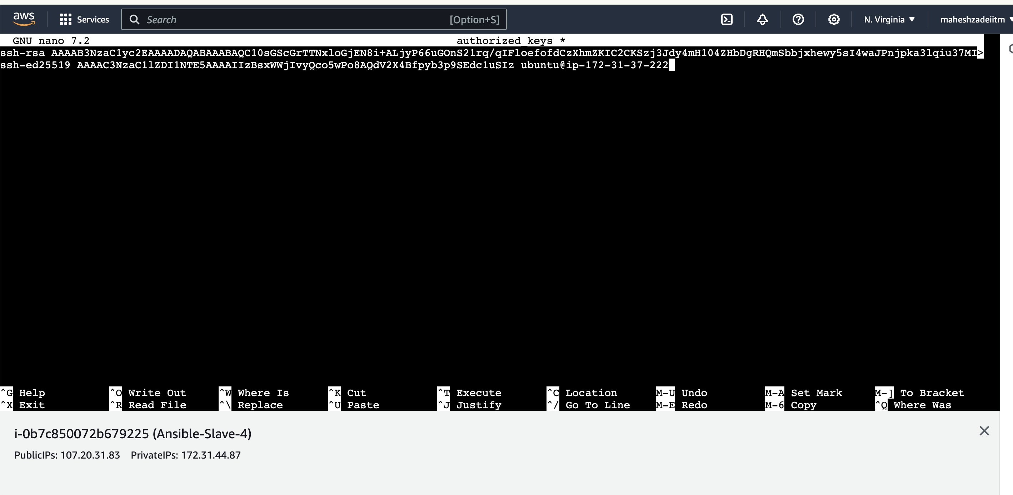

**Edit the host file from below path**

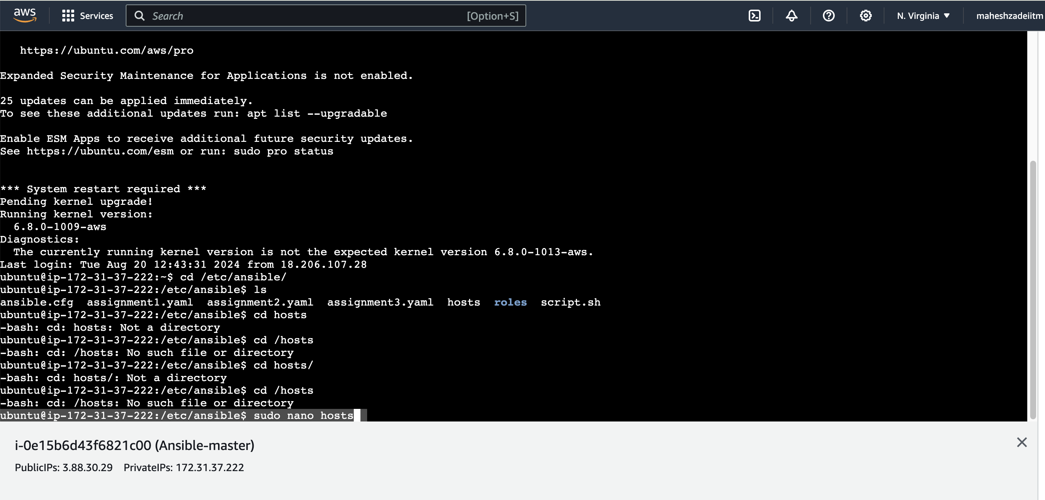

* **Slave 1 and Slave 2 make them as TEST in hosts file (old machines)**
* **Slave 3 and Slave 4 make them as PROD in hosts file (new machines you created for this assignment 5)**

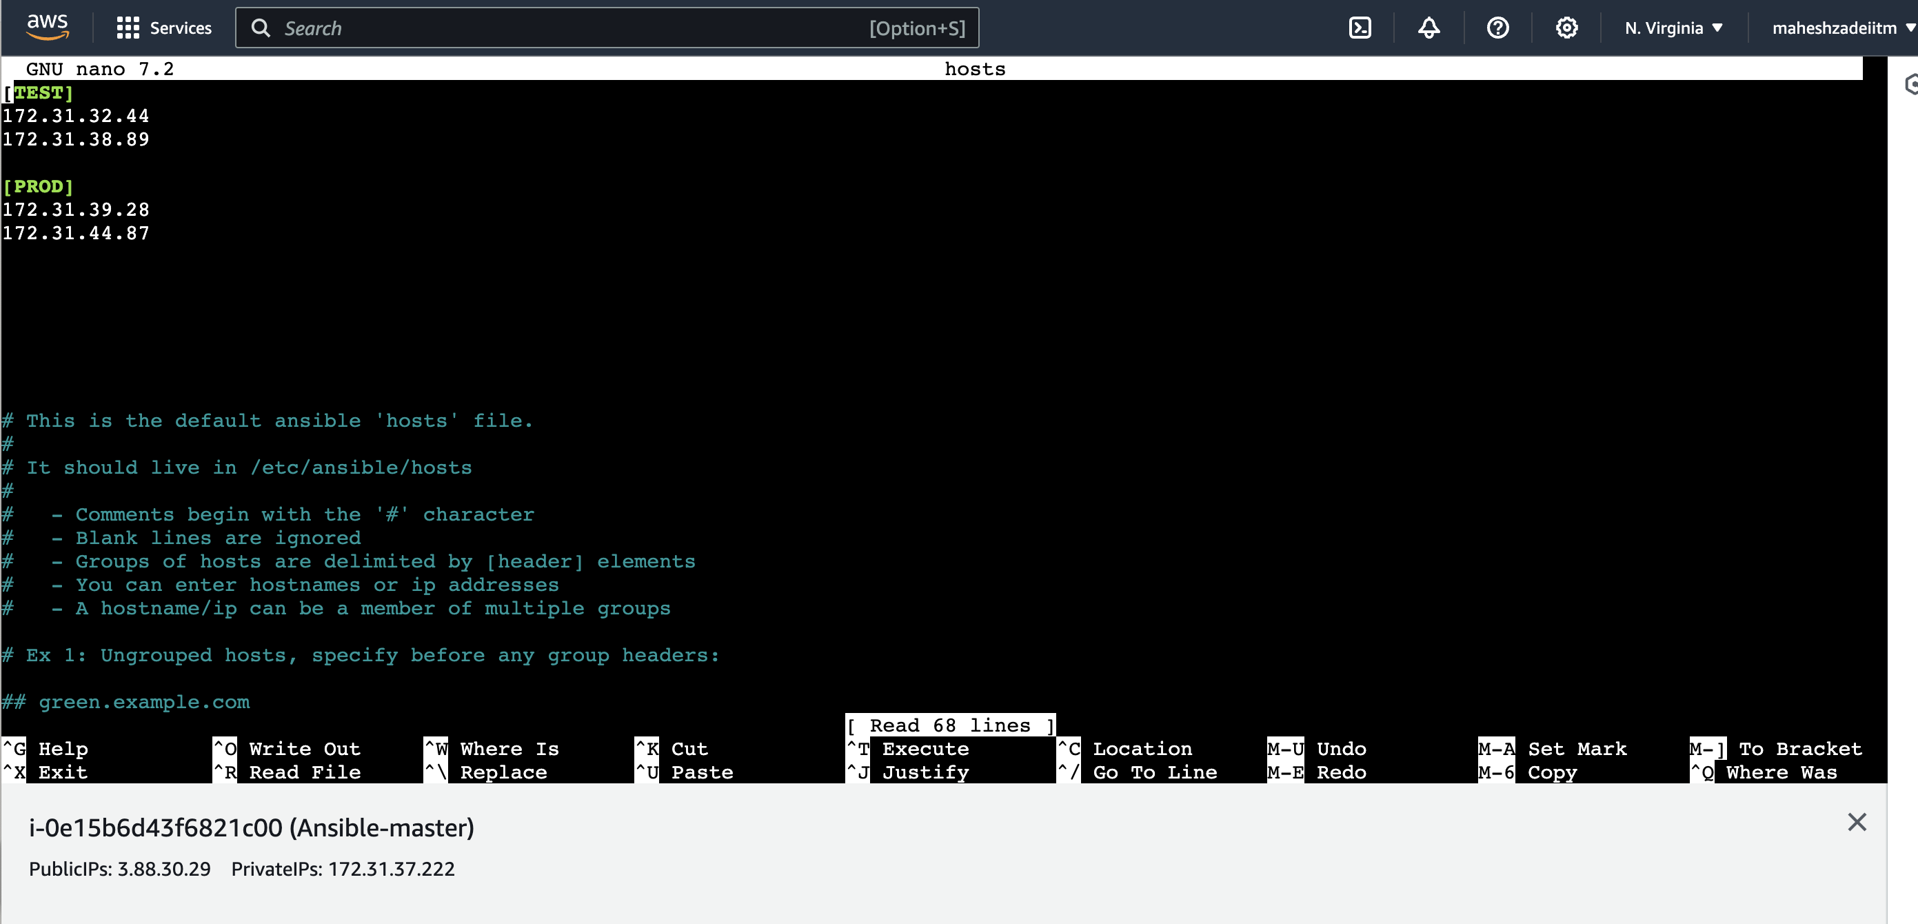

**Check the ping to TEST and PROD GROUP**

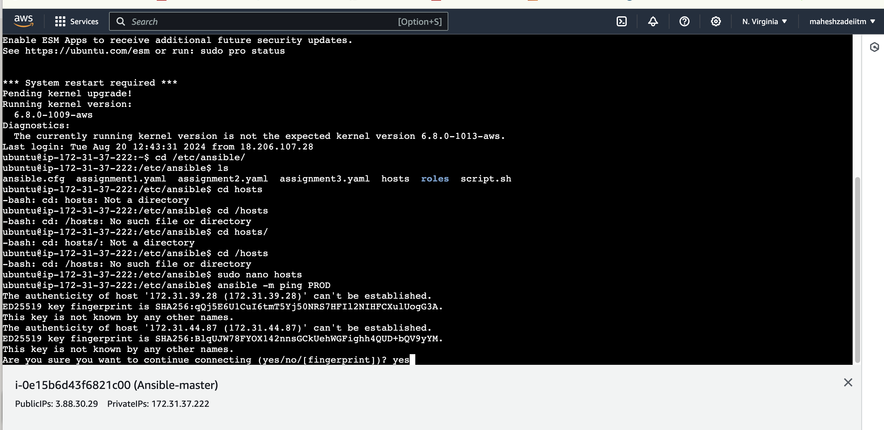

* **Ping the new group:**
* **Ansible -m ping PROD**

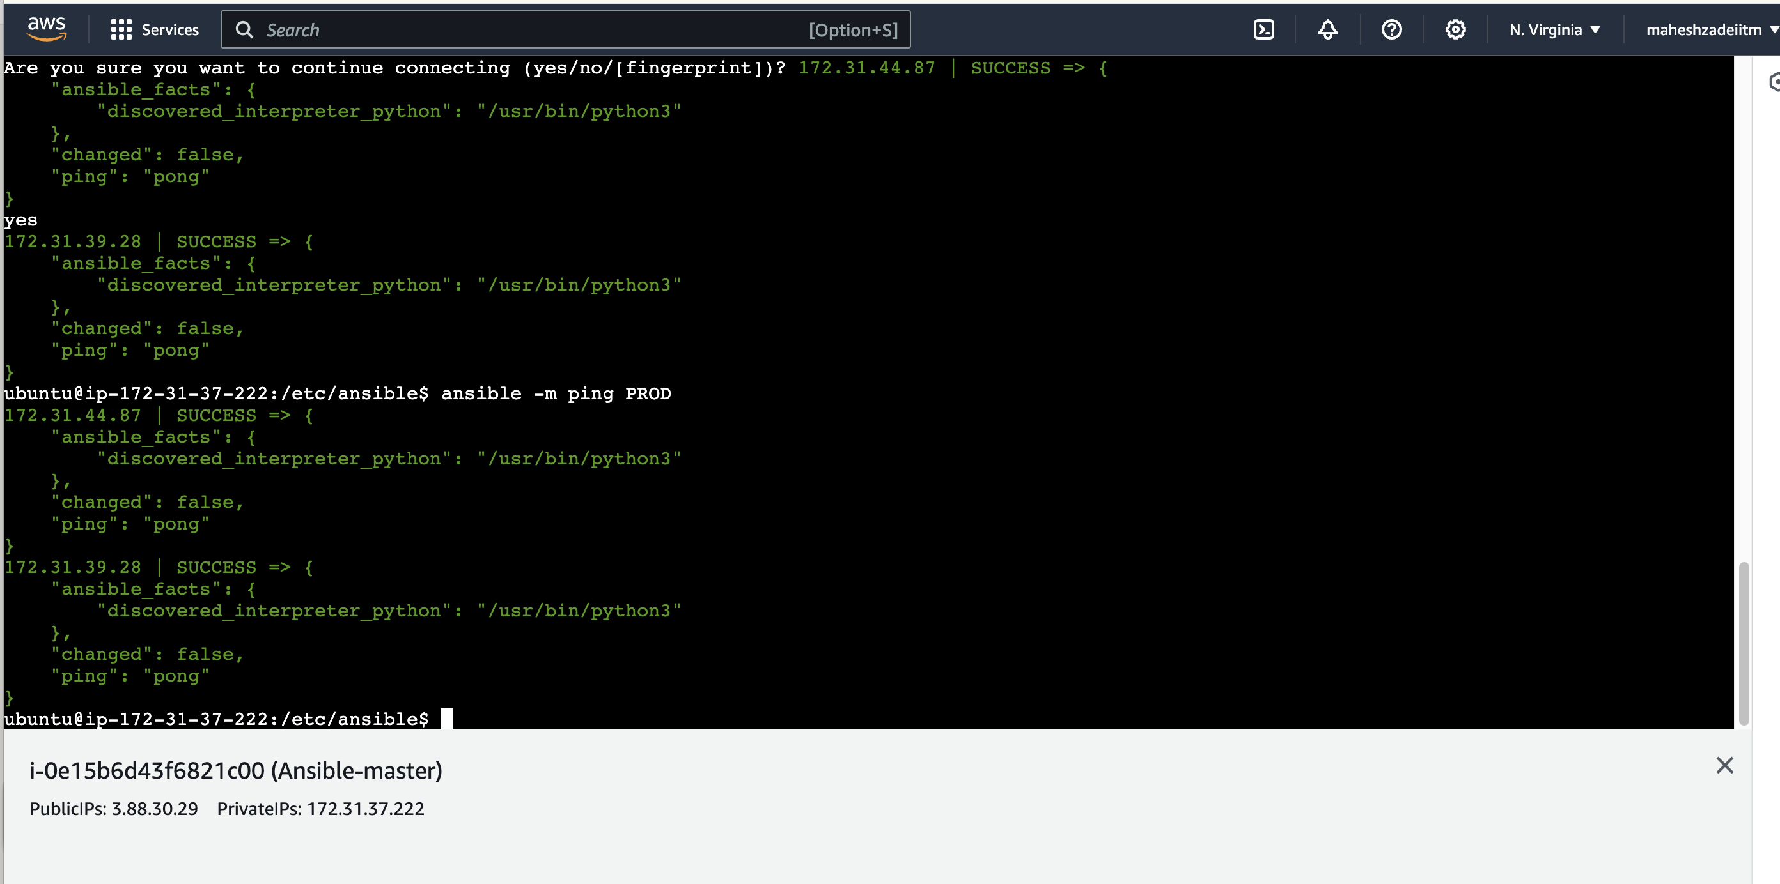

* **Create a playbook and run it:**
* **Playbook run successfully as per below command**

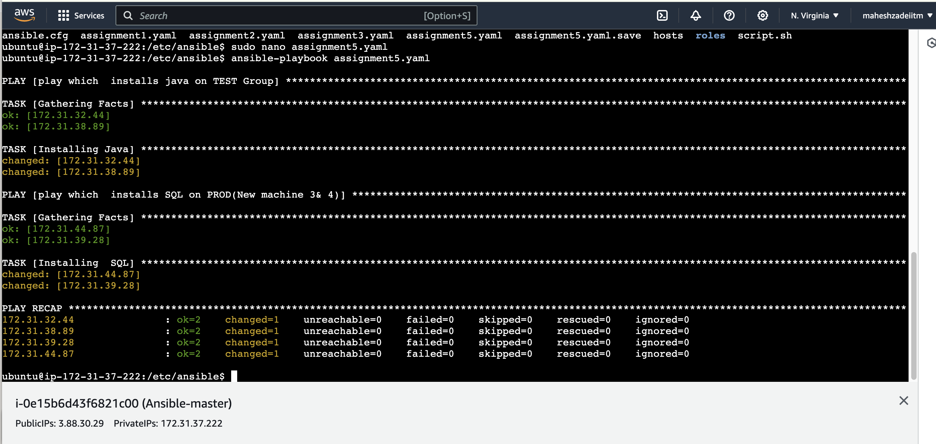

* **Now check the Java 17 is installed from java 11 in Slave 1 and Slave 2 in test Group**

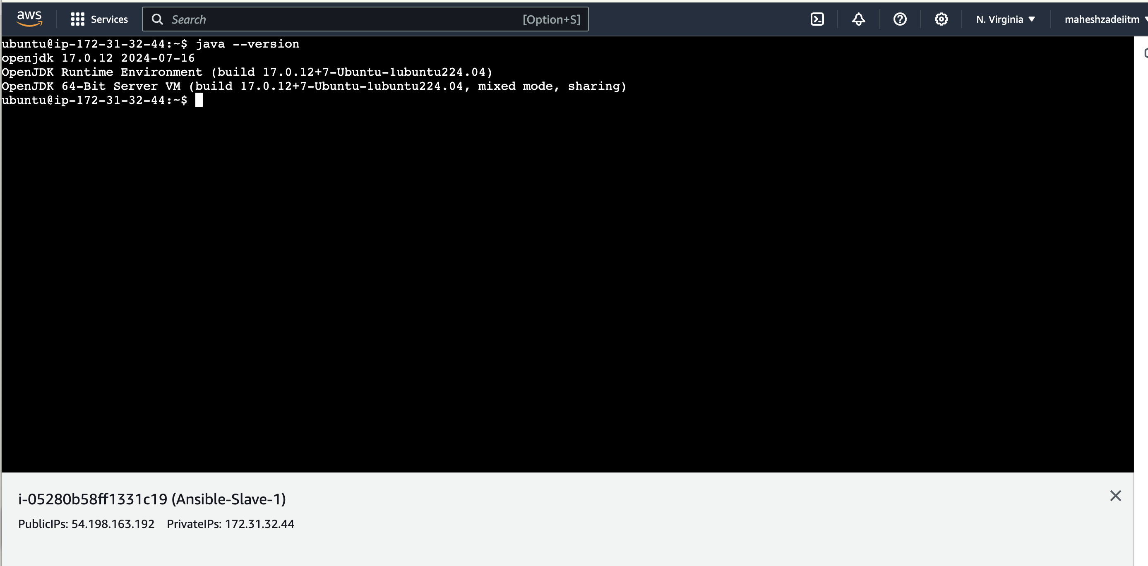

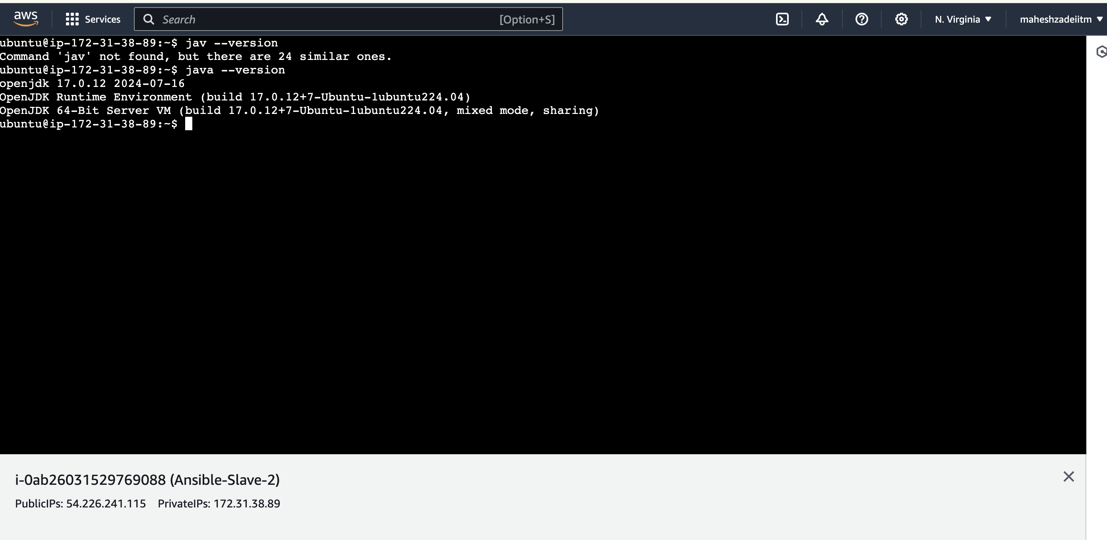

* **Now check the mysql is installed in Slave 3 and Slave 4 in PROD Group**

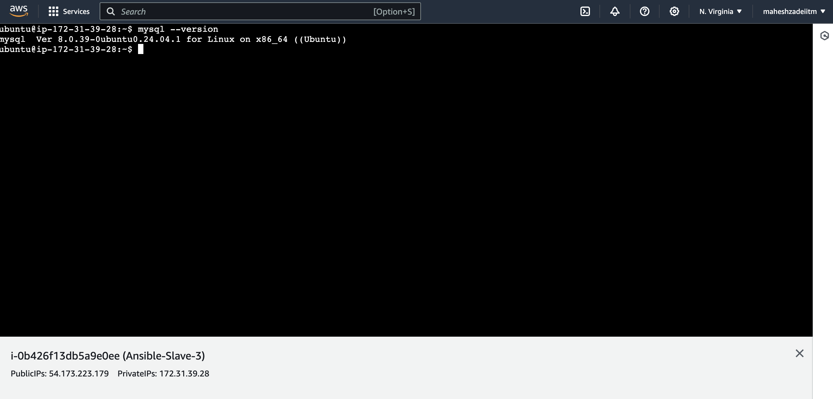

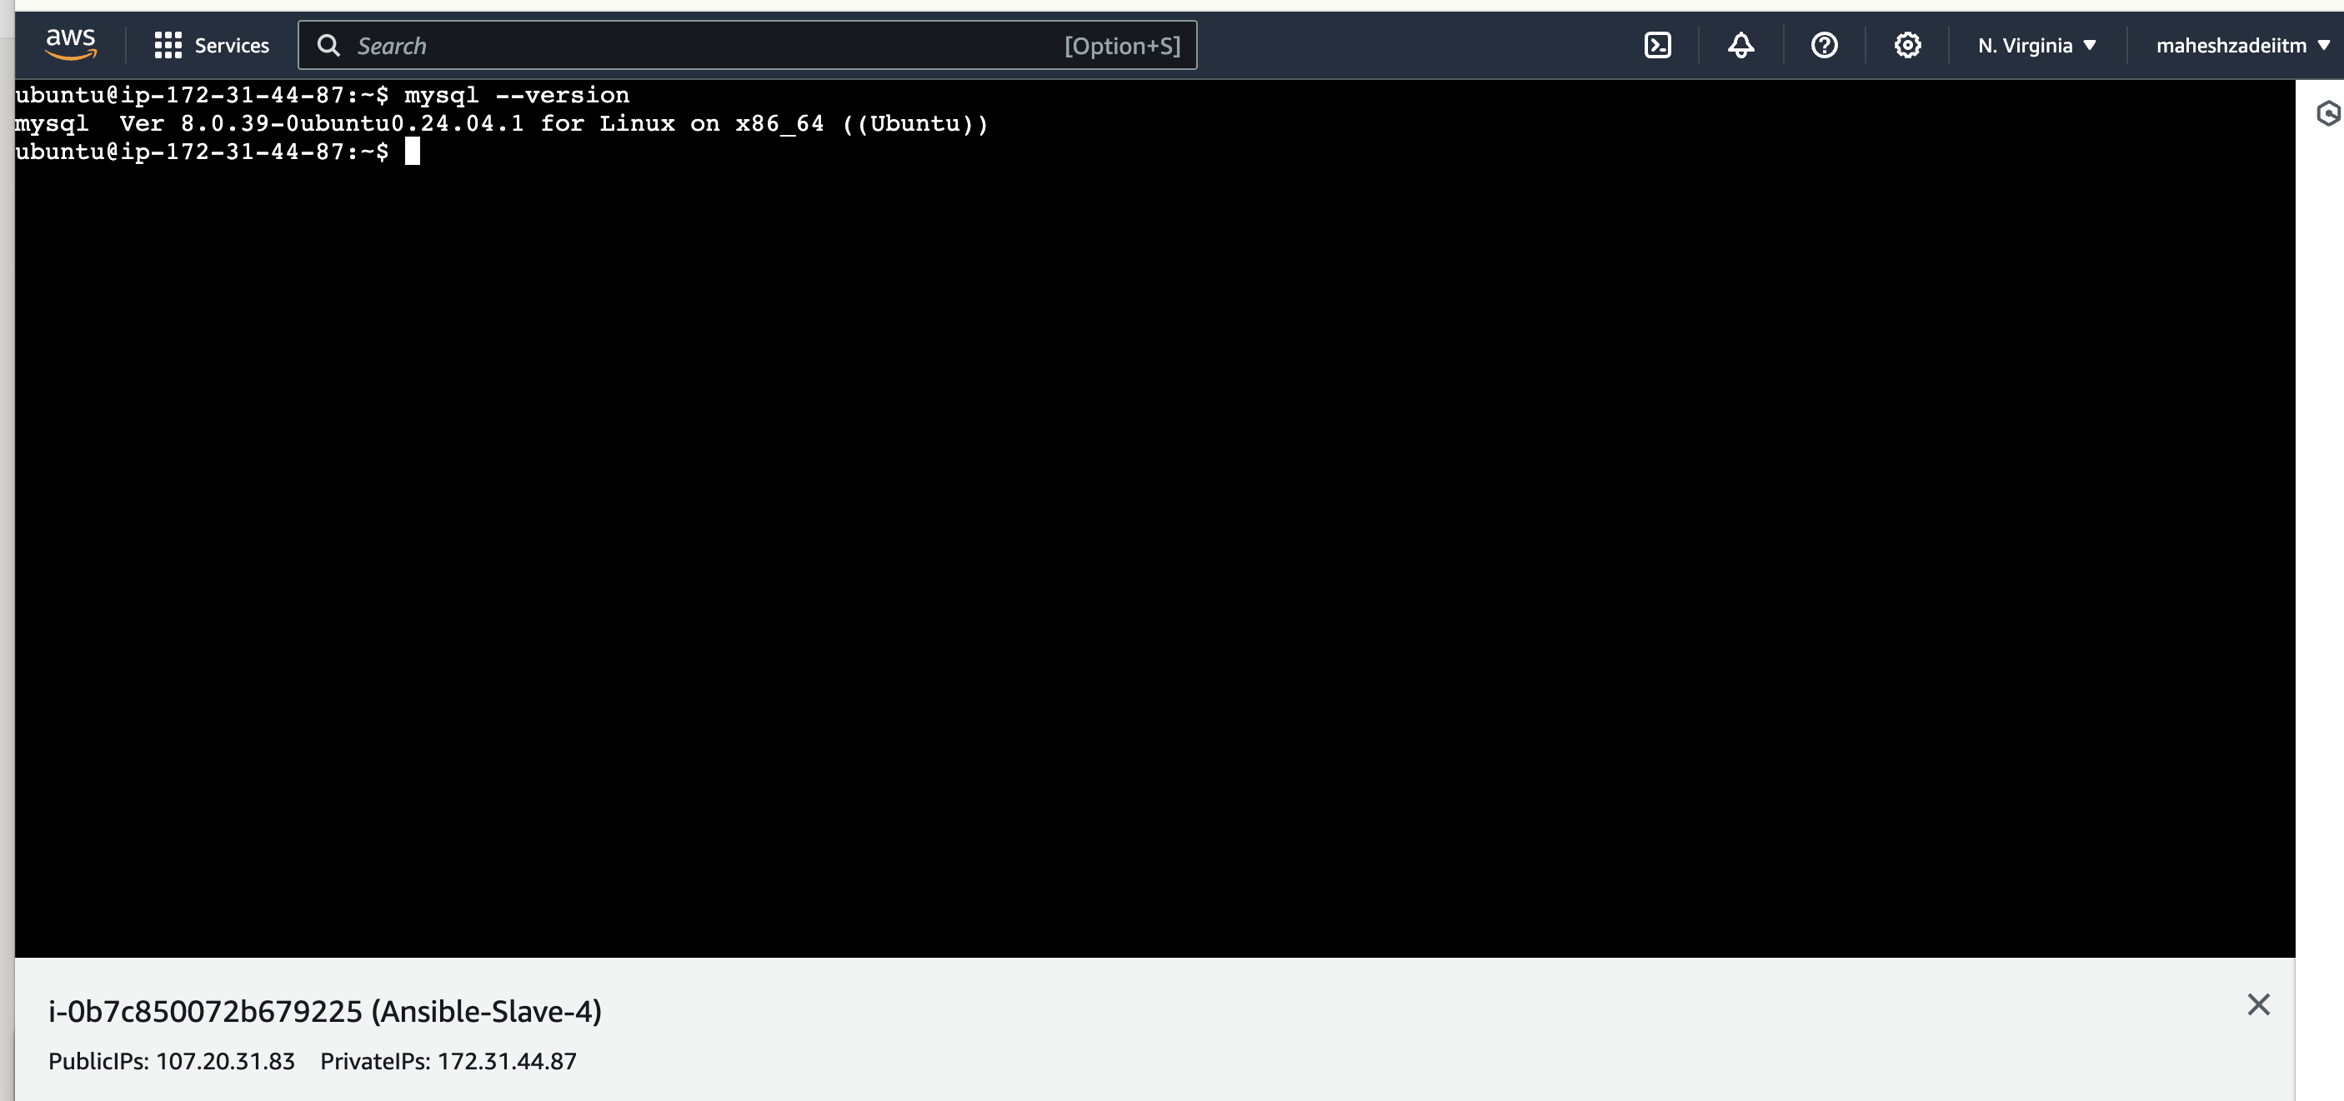

Ansible assignment 5 completed successfully.

Thanks